Clausal Analysis
Table of contents

Clausal analysis: Definition 1
Parsers for clausal analysis1
Sentence Level Tags 1
Phrase Level Tags 2
Prepositional Phrases (PP) 3
What clausal analysis says about style 3
Other useful tools 3
Sentence complexity 4
Visualizing the parse tree 4
Text readability 4
Unusual words 4
n-grams and hapax legomena 4
References 4

Clausal analysis: Definition

Clausal analysis involves the division of sentences into their constituent clauses: for example, the analysis of the sentence “When the bell rang, all the children ran out of the classroom.” “all the children ran out of the classroom” is the main clause, and “When the bell rang” is a subordinate adverbial clause of time. This type of analysis was once standard practice in schools, based on the study of Latin. But from the 1960’s the practice was slowly abandoned in the English-speaking world and students have generally had little organized instruction in sentence forms. Natural Language Processing (NLP) parsers provide automatic ways of clausal analysis.

Parsers for clausal analysis

Clausal analysis is based on the CoNLL table produced by the selected NLP parser. Stanza (the default NLP package) provides both dependency and constituency parsing. spaCy provides dependency parsing. Stanford CoreNLP provides PCFG and neural network parsers.

Note: The Stanford CoreNLP neural network parser does NOT produce clausal tags (only the PCFG parser). Stanza constituency parsing does produce clausal tags.

The clausal tags used by the parsers are based on the Penn Treebank Project (https://web.archive.org/web/19970614160127/http://www.cis.upenn.edu/~treebank/)

Sentence Level Tags

S | Sentence – simple declarative clause, i.e. one that is not introduced by a (possible empty) subordinating conjunction or a wh-word and that does not exhibit subject-verb inversion.
SBAR | Subordinate clause. Clause introduced by a (possibly empty) subordinating conjunction.  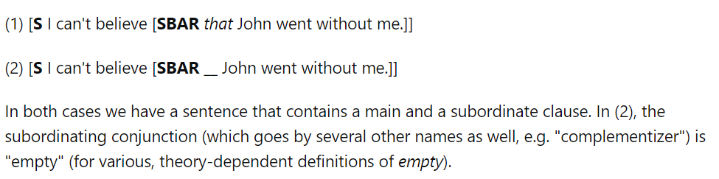
SBARQ | Direct question introduced by a wh-word or a wh-phrase. Indirect questions and relative clauses should be bracketed as SBAR, not SBARQ.  John shuddered to think what the neighbors would say…  May wondered who else had a key to the door…
SINV | Inverted declarative sentence, i.e. one in which the subject follows the tensed verb or modal.  “‘You will beat them,’ he said, and-marking the town of Preston with his thumbnail on the map – ‘you will beat them there!’ And on November 13, beaten there they were.” Winston Churchill, The Birth of Britain
SQ | Inverted yes/no question, or main clause of a wh-question, following the wh-phrase in SBARQ.  Where was John, and what was he doing?

Phrase Level Tags

ADJP | Adjective Phrase.
ADVP | Adverb Phrase.
CONJP | Conjunction Phrase.
FRAG | Fragment.
INTJ | Interjection. Corresponds approximately to the part-of-speech tag UH.
LST | List marker. Includes surrounding punctuation.
NAC | Not a Constituent; used to show the scope of certain prenominal modifiers within an NP.
NP | Noun Phrase.
NX | Used within certain complex NPs to mark the head of the NP. Corresponds very roughly to N-bar level but used quite differently.
PP | Prepositional Phrase.
PRN | Parenthetical.
PRT | Particle. Category for words that should be tagged RP.
QP | Quantifier Phrase (i.e. complex measure/amount phrase); used within NP.
RRC | Reduced Relative Clause.
UCP | Unlike Coordinated Phrase.
VP | Verb Phrase.
WHADJP | Wh-adjective Phrase. Adjectival phrase containing a wh-adverb, as in how hot.
WHAVP | Wh-adverb Phrase. Introduces a clause with an NP gap. May be null (containing the 0 complementizer) or lexical, containing a wh-adverb such as how or why.
WHNP | Wh-noun Phrase. Introduces a clause with an NP gap. May be null (containing the 0 complementizer) or lexical, containing some wh-word, e.g. who, which book, whose daughter, none of which, or how many leopards.
WHPP | Wh-prepositional Phrase. Prepositional phrase containing a wh-noun phrase (such as of which or by whose authority) that either introduces a PP gap or is contained by a WHNP.
X | Unknown, uncertain, or unbracketable. X is often used for bracketing typos and in bracketing the...the-constructions.
0 | 'Zero variant of "that" in subordinate clause'

Prepositional Phrases (PP)

The Britannica Dictionary (https://www.britannica.com/dictionary/eb/qa/All-About-Prepositional-Phrases#:~:text=Answer,adjectives%2C%20adverbs%2C%20and%20verbs) provides the following definition and examples of prepositional phrases.

A prepositional phrase is a group of words that begins with a preposition and ends with a noun, pronoun, or noun phrase (this noun, pronoun, or noun phrase is the object of the preposition).

Prepositional phrases modify or describe nouns, pronouns, adjectives, adverbs, and verbs. They say something about the relationship between their object and the word they describe/modify. Prepositional phrases can tell us when [time] or where [location] something is or something happened. They can tell us the direction something is or is moving/going. They can tell us something about the word or words they describe.

In the phrase “the girl with the long hair” the prepositional phrase is “with the long hair.” It tells us something about “the girl.”

In the phrase “the book on the table” the prepositional phrase is “on the table.” It tells us the location of “the book.”

In the sentence “I run in the morning” the prepositional phrase is “in the morning” and it modifies the verb “run” [it tells us when I run].

In the sentence “the keys are under the table” the prepositional phrase “under the table” tells us where they keys are.

In the sentence “the play starts at five o’clock” the prepositional phrase “at five o’clock” tells us when the play starts.”

In the phrase “they keys to the house” the prepositional phrase “to the house” tells us about the keys [it tells us which keys they are/what the keys are for].

In the sentence “she looked around the living room for the cat” the prepositional phrase “around the living room” tells us where she looked” and the prepositional phrase “for the cat” tells us why she looked.

What clausal analysis says about style

Sentences can be constructed in very different ways, with a mixture of the different types of clauses, of different types of combinations of phrase types. As John O’Hayre writes in his Goobledygook Has Gotta Go (1966):

Well-handled inversion (SINV tag) makes for true and interesting variety. Winston Churchill, a master of the long sentence, was also a master of the inverted sentence; see how effectively he uses inversion in this sentence from The Birth of Britain: “‘You will beat them,’ he said, and-marking the town of Preston with his thumbnail on the map – ‘you will beat them there!’ And on November 13, beaten there they were.”

Clausal measures (e.g., SINV for inversion) and plots in the NLP Suite provide ways of tapping an author’s style.

See also the TIPS file on style.

Other useful tools

Sentence complexity

You can compute measures of sentence complexity using the java script Sentence_Complexity.jar.

Visualizing the parse tree

Do try visualizing the parse tree using the java script dependenSee.jar.
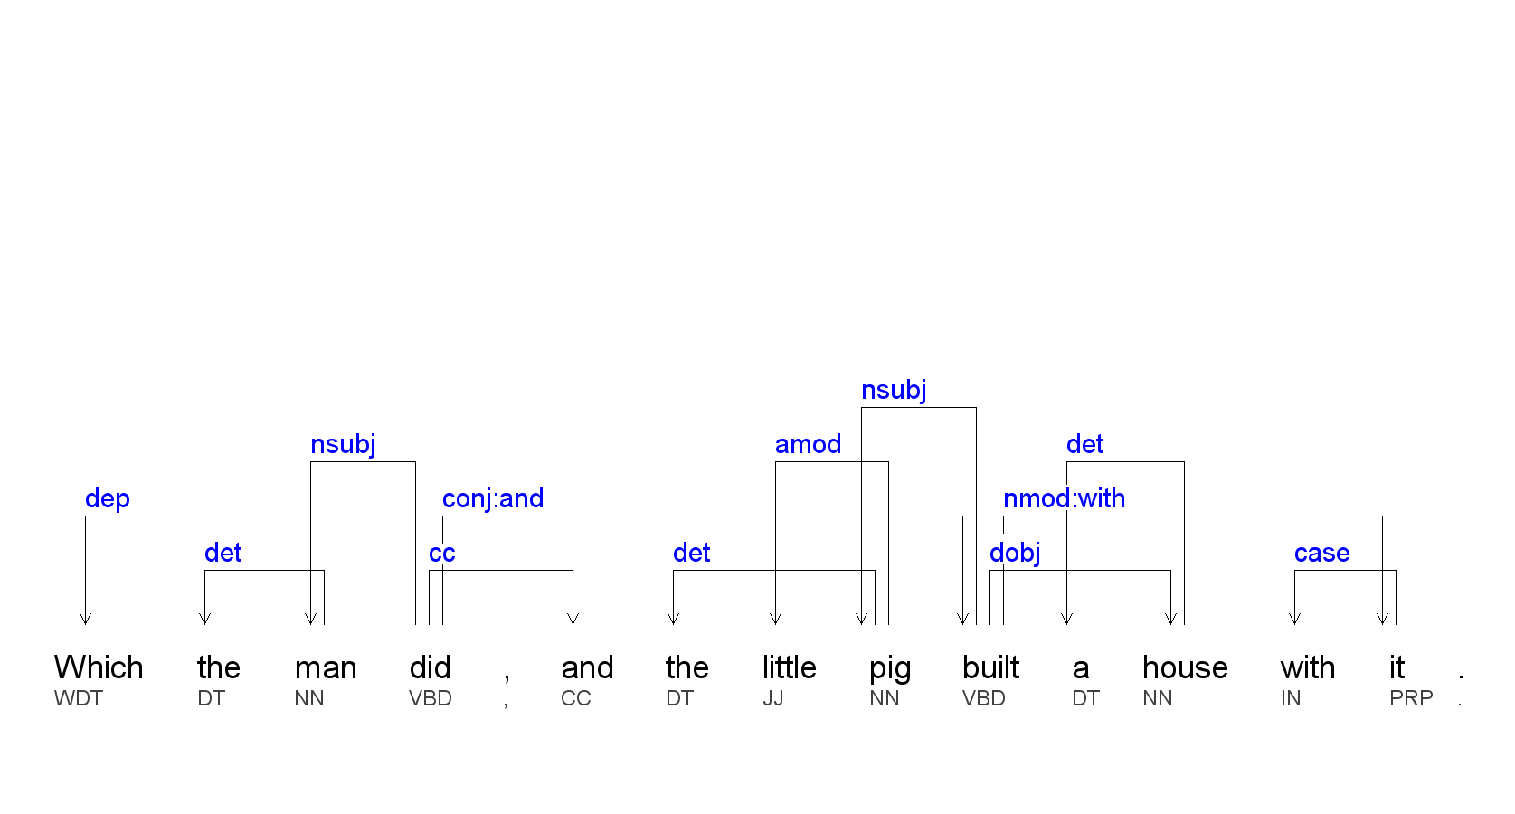

Text readability

The text readability script provides several measures of readability, in terms of how many years of formal education it takes to understand a text, starting from grade 1 (of the American education system).

Unusual words

Unusual words (and not just because a word is misspelled) do not contribute to sentence complexity at the syntactical level but they do contribute to text readability at the semantic level. Run the NLTK algorithm to get a list of unusual words in your documents.

n-grams and hapax legomena

n-grams and words that only occur once in a text (called hapax legomena, singular legomenon, often abbreviated to hapax) often provide clues to an author’s use of language.

References

O’Hayre, John. 1966. Goobledygook Has Gotta Go. Washington, D.C.: U.S. Government Printing Office No. 0-206-141.

